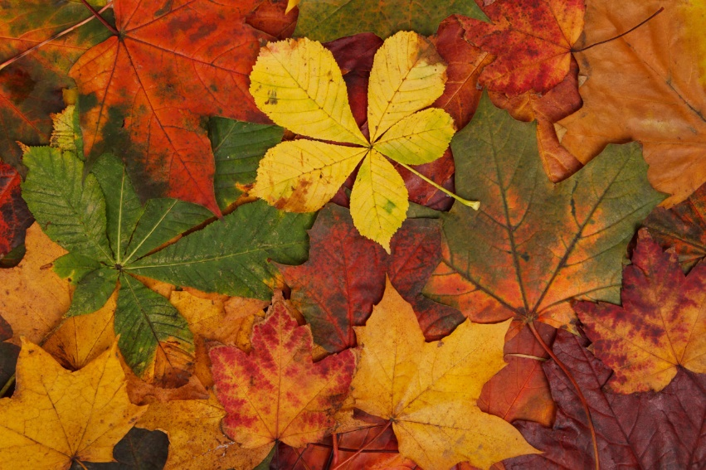
History
Southport in the 1960’s

Geography
What is a map?
PE
Gymnastics, Fundamentals,
Ball Skills, Invasion Games

Music
Pulse, Rhythm and Pitch
Design Technology
Making Healthy Pizzas
Art and Design
Self Portraits
Peter Blake

Year 2
Autumn Termly Overview
Religious Education
Creation and Covenant
Prophecy and Promise

Computing
Information Technology Around Us

English
Meerkat Mail
Wanted! The Perfect Pet
Pumpkin Soup
Firework Poetry

Science
PSHE
Community
Similarities and differences between people
Making informed choices
Types of bullying
Healthy Lifestyles
Animals Including Humans
Maths
Place Value
Addition and
Subtraction
Geometry: Shape

