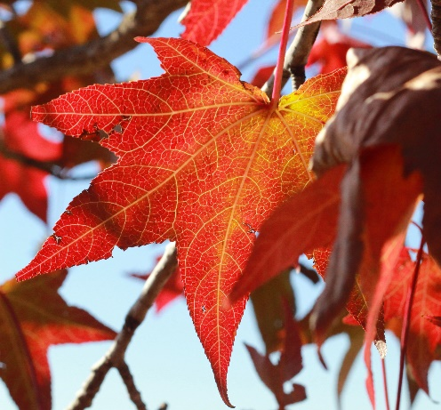
Religious Education
Creation and Covenant – God is love. God made a wonderful world. We must take care of God’s world. The words and actions of the Sign of the Cross.
Physical Development
Cutting skills and joining materials
Outdoor play
Fine motor activities
Dough Disco

PE
Get Set 4 PE: Introduction to PE.
Personal Social and Emotional Development
Settling in and making friends
Sharing and taking turns
Being confident to try new activities

Literacy
Focus Texts: The Gruffalo and other Julia Donaldson stories
Phonics: Phase 1 blending and segmenting skills. Phase 2 Sets 1-3.
Writing: write our name with a capital letter and correct formation. Hearing and saying initial sounds in words.
Reading: listen to enjoy and talk about a range of texts. Link sounds to letters. Blend sounds in words.
Autumn Term 1
Reception
Music
Charanga Music: Me!

Maths
Counting Skills
Shape
Pattern
Expressive Art and Design
Self-portraits and drawing skills
Colour mixing and exploring the colours of the rainbow.
Autumn trees and leaf rubbings

Understanding of the World
Where do I live?
My family
What is the past and the present?
Exploring Autumn
Recognising types of technology in our lives.
Dragging and dropping items using a mouse

Communication and Language
Sharing weekend news
Developing listening skills in large and small groups
Learning new vocabulary
Asking questions and engaging in story times

