

St. Patrick’s Catholic Primary School

Reception 2026

Welcome to St. Patrick’s Catholic Primary School!
We are so excited that you are going to be starting our Reception and cannot wait to get to know you and to help you make lots of new friends. Being in Reception is the most wonderful adventure where you will play and learn new skills every day. By the end of the year, you will be able to do so many amazing things. You will have explored the world around you and most importantly had so much fun!
This book is to help you understand what being in Reception at St. Patrick’s will be like. It is written for you (with a few bits of extra information for your grown-ups).
We hope you enjoy looking at the pictures and that this helps you to get as excited about school as we all are!
Our Mission and School Values
Faithfully following in the footsteps of Jesus, we serve, love and learn together, inspiring each other to excellence.
Every day all members of our school community try their best to live out our Mission Statement. Each year in September, we have a special Mission Day to celebrate our Mission Statement and reaffirm our commitment to follow in Jesus’ footsteps. We actively seek opportunities to share the love of Christ, look for ways to be of service and inspire others with our actions.
In September 2023, as part of our annual Mission Day, children worked together to determine our school values. They had lots of wonderful ideas about what makes our school so special and decided on the following:

Helping Others (Altruism)
Friendship
Courage
Respect
Trust
Loyalty

Each half term we focus on one of our values and why it is important to our community. Children explore and think about these values in assemblies and within their classes, showing us all what a difference they make to our school family.
Our Staff
All the staff at school are excited to meet you and help you on your St Patrick’s journey and you will get to know them very quickly once you start school.
The teachers in Reception are:

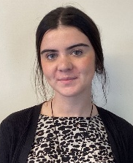
Mrs S Grant Mrs R Shirley Miss L Benson
Class Teacher EYFS Lead Class Teacher

KEY DATES
Transition Morning 1: Thursday 25th June 2026
Transition Morning 2: Thursday 9th July 2026
Start School: Wednesday 2nd September 9.30am

From Thursday 3rd September: 8.55am – 3.15pm

How will we get to know you?
Nursery Visits
In May, Mrs Shirley came to visit all of you at Nursery. It was lovely to see you playing with your friends and we chatted with you and your Nursery teacher to find out all about you and what you like to do.
Visiting Your New Classroom
Before you start school in September, you will be able to visit school and to see your new classroom on our Transition Mornings. There will be lots of toys out that you can play with and lots of new friends that you will get to meet.
These will take place on:
Thursday 25th June 2026
Thursday 9th July 2026
There is additional information in your Welcome Pack about what time to attend. We have invited your nursery friends to come to the same time slot as you so that you know some familiar faces.
The Transition Mornings are a great opportunity for us to get to know you better before September. (We encourage parents and carers to drop off and collect rather than stay for the duration of the session so that children understand what it will be like when they start school).
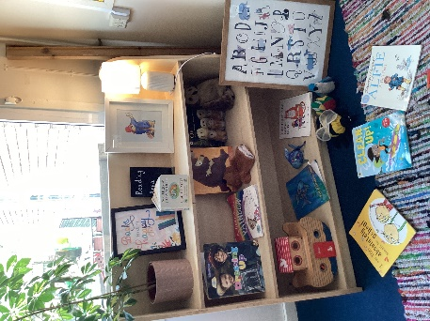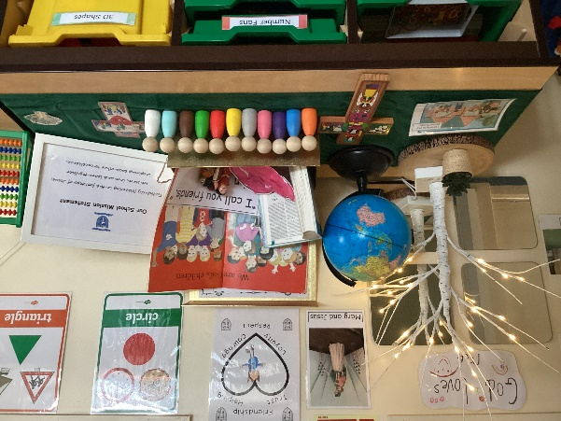
Home Visits
We can also visit you at home if your parents feel this would be helpful or would like to speak to your teacher confidentially.
Please speak to Mrs Shirley if you would like to arrange a home visit. These will take place in July.

Starting School
On your first day your grown-up will take you to your classroom door where you will meet your teachers. Then you will be able to give them a big hug and say good-bye. Don’t worry though, your grown-up always come back at the end of the day for big cuddles and to find out all about what you have been up to!
Everyone comes to school all day from the very first day so you will get to meet all your new friends as well as seeing some of your old nursery friends.
Your will start school on:
Wednesday 2nd September 9.30am – 3.15pm
We start a little later on this day so that all the other children are already in class and the playground is quiet.
The first few weeks can be tiring and bewildering even if your child is used to Nursery or being with a childminder. Don’t worry if your child becomes upset; we are used to dealing with this situation. Children usually stop crying quickly and we can phone you to reassure you later in the session.
We have two Reception classes
From Thursday 3rd September you will start school at 8.55am.
Our School Day in Reception is organised as follows:
Early Doors 8.45am
School Starts 8.55am
Lunch 11.25am - 12.20pm
Home time 3.15pm
Breakfast and After-School Club
ZigZags offers wrap around care at St. Patrick’s Catholic Primary School.
The times are:
7.30am – 8.45am (children are then delivered to their class)
3.15pm - 6.00pm
Breakfast and afternoon snacks are provided.
Please contact ZigZags for more information:
Julie: 07850 738670
Lunchtime
Hot school dinners are FREE for all children in Reception, Year 1 and Year 2.
Our meals are prepared on the premises. Menus run on a three-weekly cycle. A menu is included in your Welcome Pack: please can this be returned to school on one of the Transition Mornings so that we are prepared for your child’s first day in September.
Alternatively, you may provide your child with his/her own packed lunch from home.
Snack Time
We run a snack scheme and have a healthy snack each morning. This costs £1 per week and is payable to your child’s class teacher. We will send out more information about this in September.
Additionally, children receive a piece of fresh fruit or vegetable and a drink of milk free of charge as part of the National Fruit for Schools’ Scheme.
Please provide your child with a water bottle to bring to school each day. Water only please.
Attendance
At St. Patrick’s Catholic Primary School attendance is a key priority. Absence, particularly in early education, has a considerable effect on children’s development. If your child is away from Reception because of any illness please notify us as to the reason on the first day and any subsequent days of absence. We strongly discourage parents to book holidays in term time. These cannot be authorised and may result in a fine.
If your child suffers from a medical condition requiring treatment such as an inhaler, we will require up to date medication to be kept in school.
It is important that we can always contact parents in cases of emergency and require two emergency contacts for each child.
Please inform school immediately if your telephone number changes.
Children with vomiting or diarrhoea should remain at home for 48 hours after their symptoms have stopped.
Medicine
Staff will administer medicine if it is required during the school day. A parental consent form must be completed which can be accessed from the office.

School Uniform
Winter Uniform:
- Light blue shirt
- School tie
- Blue school jumper or cardigan with logo
- Grey trousers, shorts, skirt or pinafore
Summer Uniform:
- Light blue checked summer dress or:
- Light blue polo shirt
- Grey trousers, shorts, skirt or pinafore
- Blue school jumper or cardigan with logo
Children may wear the summer uniform up until autumn half term in October.
Children should wear black, sensible shoes (not boots) with a Velcro or buckle fastening.
Jewellery and nail varnish are not allowed in school.
PE Kit:
- White t-shirt or polo shirt
- Navy shorts or plain navy leggings/joggers
- Trainers
Your child should come into school in their kit on PE Day each week. The day for PE will be confirmed by your child’s Class Teacher in September.
Book Bags
We recommend that your child has a school book bag. They are very useful for carrying your child’s reading books, party invitations and important letters home.
We cannot emphasise enough the importance of naming everything. We do our best to help the children put their things away, but it is far easier to locate a missing jumper in the classroom if it is named. Also remember to put a name label in shoes and coats as many children often have similar ones!
Where will I put my things?
You will have your own peg where you can hang your coat and your own tray where you can keep you pictures and art work.
Your child does not need to bring any of their own toys in to school. We have plenty of fun things to play with here and we don’t want their toys to get accidentally lost or broken.
The Early Years Curriculum
Our Early Years Foundation Stage Curriculum is organised to take care of and develop the whole child and not just their academic learning. Our EYFS curriculum is split into 7 areas of learning:
- Communication and Language. This underpins all seven areas of development. We create a language-rich environment and read frequently to children engaging them actively in stories, non-fiction, rhymes and poems. Children are given extensive opportunities to use and embed new words in a range of contexts.
- Physical Development. This is vital in children’s all-round development. We support children to develop their core strength, stability, balance, spatial awareness, coordination and agility. Fine motor skills are developed using repeated and varied opportunities allowing children to develop proficiency, control and confidence.
- Personal, Social and Emotional Development. Children are supported to manage their emotions, develop a positive sense of self, set themselves simple goals and have confidence in their own abilities. They learn how to look after their bodies, manage personal needs and make good friendships.
- Literacy. Reading is at the heart of our curriculum and children are encouraged to develop a life-long love of reading which consists of language comprehension and word reading. In writing they learn how to form letters correctly, segment words for spelling and begin to write simple sentences that they compose themselves.
- Mathematics. Children will be able to count confidently. They will develop a deep understanding of the numbers to 10 using small objects and tens frames to build this understanding and develop a secure base of knowledge. They also learn about space, shape and measures, develop reasoning skills and look for patterns and connections.
- Understanding of the World. This enables children to make sense of their physical world and their community. Through a wide range of experiences, they develop their understanding of our diverse world.
- Expressive Arts and Design. The development of children’s artistic and cultural awareness supports their imagination and creativity. Children will have regular opportunities to engage with the arts, enabling them to explore and play with a wide range of media and materials.
Our EYFS curriculum also includes the Characteristics of Effective Learning. These focus not on what children know but how children learn.
• Playing and Exploring – our children investigate and experience things and events around them and ‘have a go.’
• Active Learning – our children concentrate and keep trying if they experience difficulties, as well as enjoying what they achieve.
• Creating and Thinking Critically – our children have and develop their own ideas, make links between different and experiences and develop strategies for doing things.

Phonics and Reading
In the autumn term we will start to learn the letter sounds and how to form letters. To do this we use a phonics and reading scheme called Pearson Bug Club Phonics. Mrs Shirley will be running an information session when we start the programme to talk about ways you can support your child’s learning at home.
Parents as Partners
At St. Patrick’s we are one big family. We are looking forward to welcoming you all and getting to know you and your families. We know that by working in partnership we can make your child’s time at school even more successful and rewarding.
We will keep you informed of our learning activities through our weekly Reception Newsletter. This will be uploaded to your child’s class page every Monday afternoon and will also give details of any home learning activities.
We regularly use a text messaging service to keep you informed of key dates/reminders and whole school newsletters are sent by email every two weeks. These are also posted on the school’s website.
Your child’s Class Teacher will be at the classroom door each morning from 8,45am greeting children and parents.

What can I do to help my child get ready for Reception?
There are some things that you can start working on with your child to make sure that they are ready for school. These include everything from practising putting their coat on to writing their names. There are also lots of other things that you can do to support your child with the transition to school. Here are a few ideas...
- All About Me bag – prepare together for sharing in September.
- Talk to them and listen to them
- Sing songs and Nursery rhymes together
- Play games with them – practise taking turns
- Read books to them and teach them to take care of books – how do you turn pages carefully?
- Visit your local library.
- Count regularly e.g. How many buttons on this dress? How many cups on the table?
- Recognise different sizes e.g. large/small or thick/thin
- Talk about shapes and colours and practise sorting and matching objects.
- Give your child the opportunity to write and draw and scribble using pens, crayons, felt tips and pencils. Can they recognise their name? Could they practise writing it?
- Practise self-care skills: go to the toilet and wash and dry hands, put on/take off coats, put on/take off shoes.
- Hold and use scissors
There are also some fantastic books and resources that you can use with your child to begin talking about starting school.
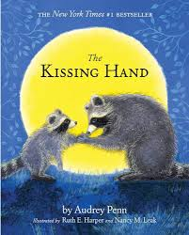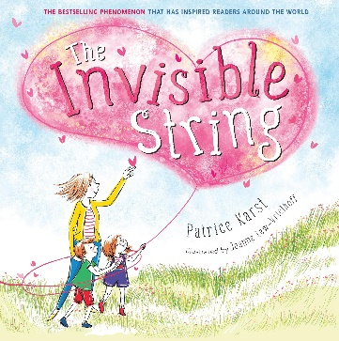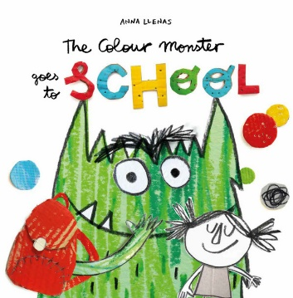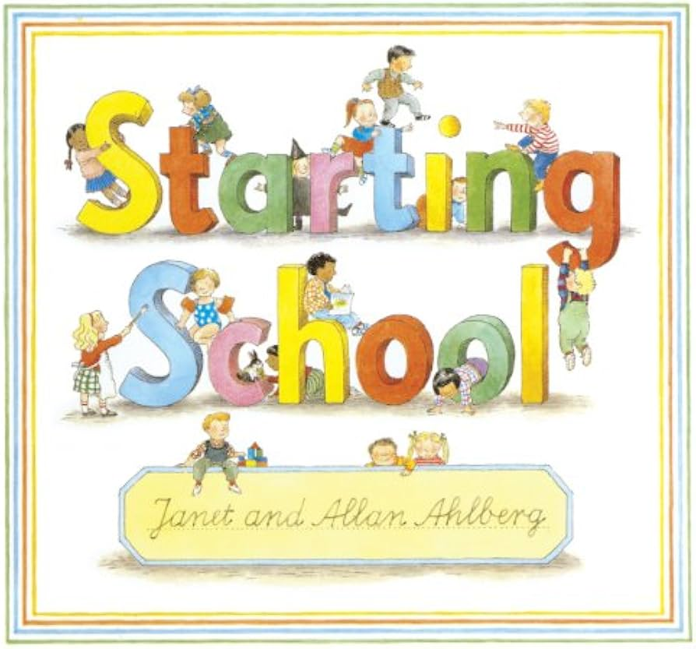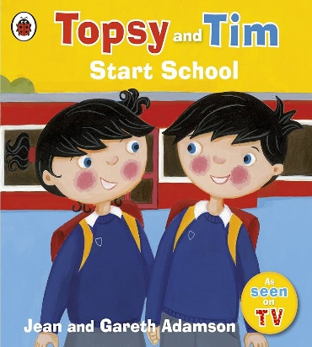
It’s good to talk…
For some of you your child’s first day of school cannot come soon enough! For others the thought of your child starting Reception may make you feel worried and anxious. However you may be feeling, one thing that we ask of you is that you talk to your child about starting school. Let them talk to you about any worries that they may have or what they are looking forward to. Show them that you are excited about the new adventure that they are about to start and use this booklet to talk about what the school day will look like for them.
We are not only here for the children, but for our parents and community too. If you ever need help, advice or support please do come and chat to us and if there is anything at all we can do to help, we will.
Thank you for reading this booklet. We hope it has given you all the information you will need before your child starts with us. If there is anything else you need to know, please do not hesitate to come and speak to us. We really are looking forward to working with you to make sure that your child has the best possible start to their time at school!

Mrs Shirley.

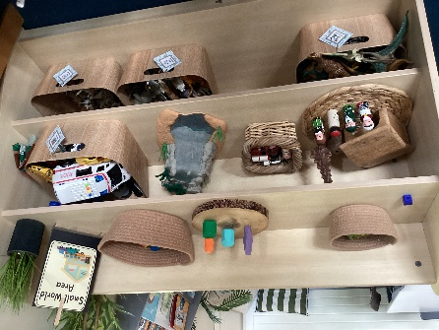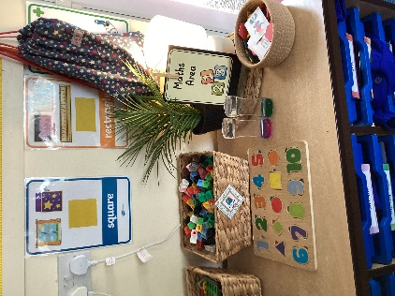

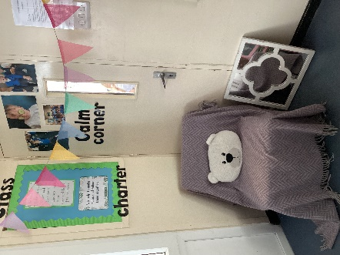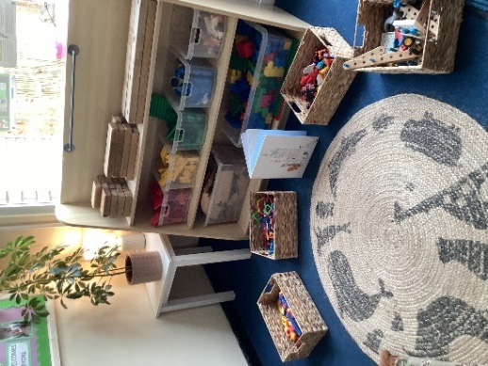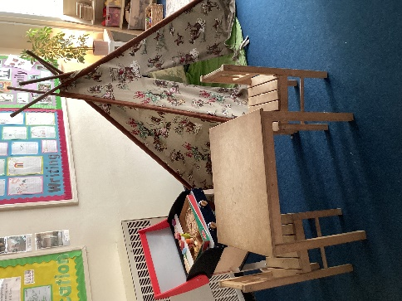

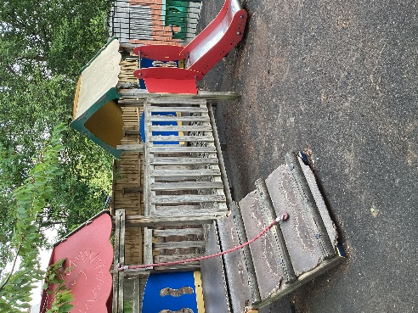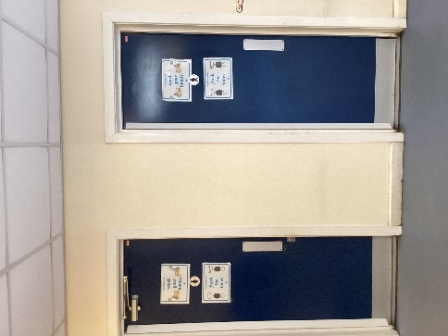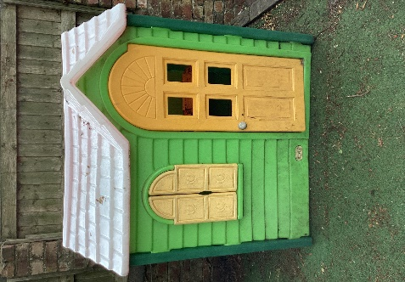
Our Outdoor Area Toilets Playhouse
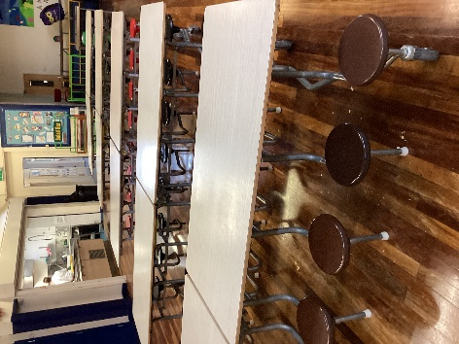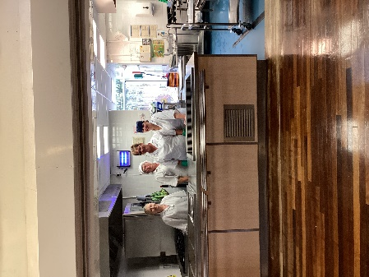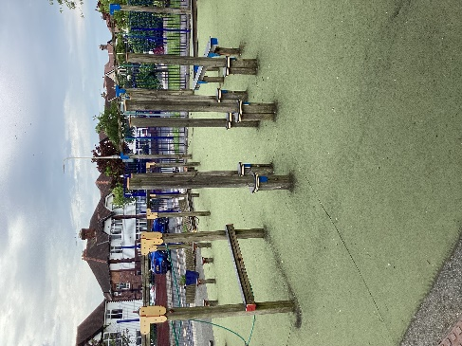
Lunch Hall Kitchen Staff Playground
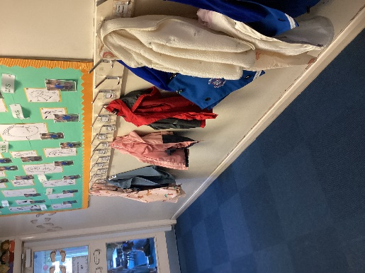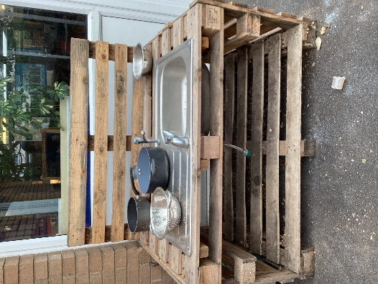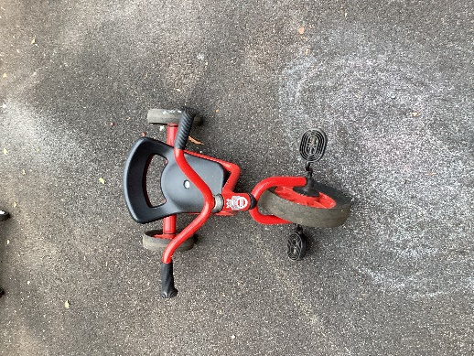
Cloakroom Mud Kitchen Scooters and Bikes

