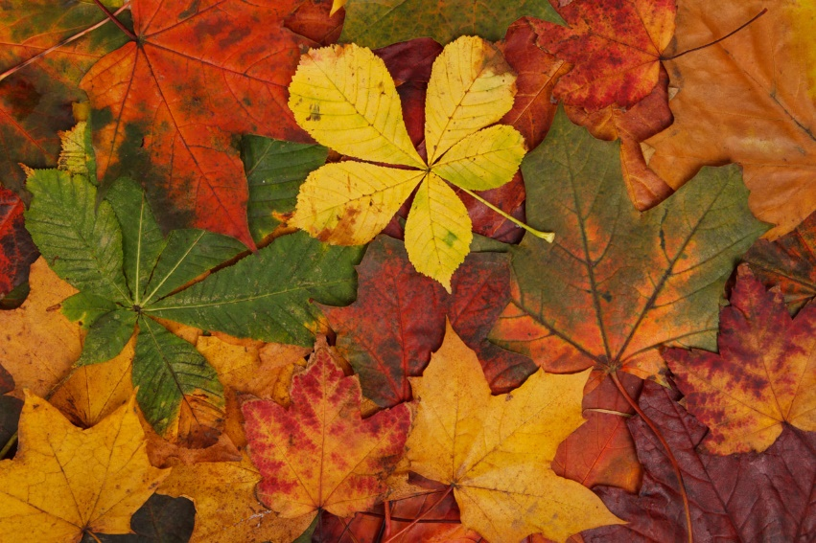
Geography
What do I know about the local area?
adults in the local area get to work
PE
Gymnastics, Football
Gymnastics, Tag Rugby
Maths
Place Value
Addition and
Subtraction
Multiplication and Division
French
I’m Learning French
Phonics 1
Animals
Music
Writing down Music
Playing in a Band
Design Technology
Prehistoric moving monsters
Science
Rocks including fossils
Animals including humans

PSHE
Types of relationships
Healthy living
People who keep us safe
Being responsible
Consequences of discrimination
Art and Design
Self Portraits
Mark Rothko
Year 3
Autumn Termly Overview
Religious Education
Creation and Covenant
Computing
Computing Systems and Networks
Creating Media
History
Our history is taught
chronologically:
Stone Age
Bronze Age
Iron Age

English
Stone Age Boy
How to Wash a
Woolly Mammoth
The Empty Stocking
Poetry

