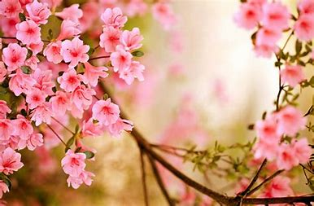

**PSHE:**

Change including transition

How can drugs common to everyday life affect health?

No Outsiders

**Book:** The Island, by Armin Greder

**Theme:** To challenge the causes of racism.

**Music:** Musical Styles Connect Us **/** Performance of our African Drumming

**Religious Education - Come and See:**

Relating - Unity (3 weeks which will take us into Spring 2)

Easter/ Giving – Death and New Life (4 weeks)

**Art:**

Art that changed the World

Michelangelo Renaissance

**Computing:**

**Data and Information**

Spreadsheets (Scratch)

**Science:**

Evolution and Inheritance (adaptation)

**Geography:**

What is a national park?

**English:**

**Picture Book**: Can we Save the Tiger? (4 weeks) Non-fiction.

**Short outcomes**: Letter, explanation, persuasive poster, poetry

**Final outcome:** To write a discussion/explanation text.

**Narrative:** Letters from the Lighthouse (2 weeks continued into summer 1).

**Short outcomes:** Newspaper, postcard, diary entry, recount.

**Final outcome:** To write a formal report in the role of a spy.

**DT and History will be taught in Summer 1.**

**Physical Education:**

Cricket and Tennis

**French:**

Me in the World

Year 6S Spring 2 Curriculum

**Mathematics:**

Fractions, Decimals and Percentages; Area, Perimeter and Volume;

Statistics