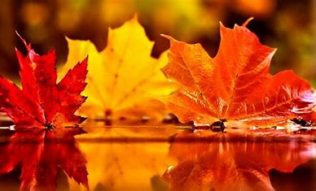

**Geography:**

What do I know about the UK?

**PSHE:**

Health & Well- Being

Relationships

Living in the Wider World

**History:**

Anglo Saxons

**Key Question:** Who were the Anglo-Saxons?How did England change with the settlement of Anglo-Saxons and Vikings?

**Computing:**

Powerpoint

Digital Literacy – Word Processing

**Art:**

Portraiture – Francis Essoua Kalu

Painting- David Hockney

**Mathematics:**

Number and Place Value

Addition and Subtraction

Statistics

Multiplication and Division

Perimeter and Area

**Physical Education:**

OAA

Swimming

Netball

**French:**

Phonics

Pets

The Date

**Religious Education - Come and See:**

Family – Ourselves

Belonging – Life Choices

Loving – Hope

Judaism

**Science:**

Properties and Changes of Materials

**Music:**

Melody and Harmony in Music

Sing and Play in Different Styles

**Design Technology:**

Using Cams to Make a Toy

**English:**

Narrative Unit: This Morning I Met a Whale – Michael Morpurgo

Instruction Texts: Link to Design Technology

Poetry: One River Many Creeks -Valerie Bloom

Year 5 Autumn Curriculum