Year 4
History
Ancient Greece What were the greatest achievements of the Ancient Greeks?
French
At the Tearoom
Phonics lesson 2
Goldilocks

Goldilocks
Spring Termly Overview
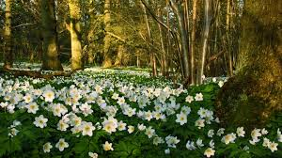
Geography
Settlements
(Contrasting Locality in UK)
English
High Quality Text – Mufaro’s Beautiful Daughters (stories from other cultures)
Newspaper Reports
Poetry
Maths
Number: Multiplication and Division
Measurement: Length and Perimeter
Number: Fractions
Decimals

Music
Ukelele
Compose With Your Friends

Science
Animals Including Humans
Sound
Art and Design
Art that changed the world
Phidias (Ancient Greece)

Religious Education –
Community
Relating - Giving and Receiving
Giving - Self-Discipline
PE
Swimming
Hockey
Cricket
Dance

Computing
Data and Information – Data Logging
Creating Media-
Photo Editing

Design and Technology
Structures – Shell Structures (Using CAD)

