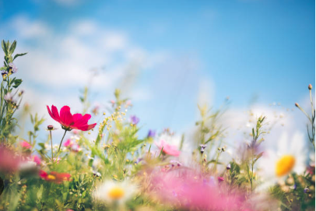

**Geography**

How does Europe compare with the UK?

**Science**

Light

Plants

**PSHE**

What makes a community?  
Who keeps us safe?  
Risk, danger, hazard  
Understanding change

**History**

Ancient Civilisations Overview

Ancient Egypt

**PE**  
Dance/Tag Rugby

Athletics/Swimming

**English**

Charlotte’s Web

Matilda

**Music**

Compose Your Imagination

More Musical Styles

**Come and See**

Local Church: Journeys  
Eucharist: Listening and Sharing  
Lent/Easter: Giving All

**Maths**

Multiplication and Division

Length and Perimeter

Fractions

Mass and Capacity

**French**

Vegetables

Musical Instruments

**Design Technology**

Healthy and Varied Diet

**Art and Design**

Art for Activism:  
Friedensreich Hundertwasser

**Year 3**

**Spring Termly Overview**

**Computing**Branching Databases

Programming