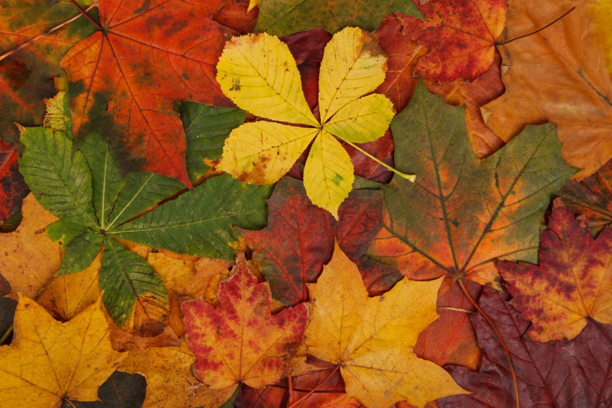

**Geography**

**What do I know about the local area?**

*adults in the local area get to work*

**PE**  
Gymnastics, Football

Gymnastics, Tag Rugby

**Maths**

Place Value

Addition and

Subtraction

Multiplication and Division

**French**

I’m Learning French

Phonics 1

Animals

**Music**

Writing down Music

Playing in a Band

**Design Technology**

Prehistoric moving monsters

**Science**

Rocks including fossils

Animals including humans

**PSHE**Types of relationshipsHealthy living  
People who keep us safe  
Being responsible  
Consequences of discrimination

**Art and Design**

Self Portraits

Mark Rothko

**Year 3**

**Autumn Termly Overview**

**Religious Education**

Domestic Church: Homes  
Baptism: Promises  
Other Faith: Judaism

**Advent/Christmas: Visitors**

**Computing**

Computing Systems and Networks

Creating Media

**History**

Our history is taught

chronologically:

Stone Age

Bronze Age

Iron Age

**English**

Stone Age Boy

How to Wash a

Woolly Mammoth

The Empty Stocking

Poetry