Art and Design
Studying Monet, using watercolours to create tints and shades. Observational drawings of trees.

Design and Technology
Creating structures.

Music
Exploring Improvisation
How does music make us happy?

Maths, R.E., PSHE and P.E. are taught as discrete subjects and linked where possible.
Summer Term
Geography
What can I see and do at the beach?

Comparing the UK and other areas in the World.
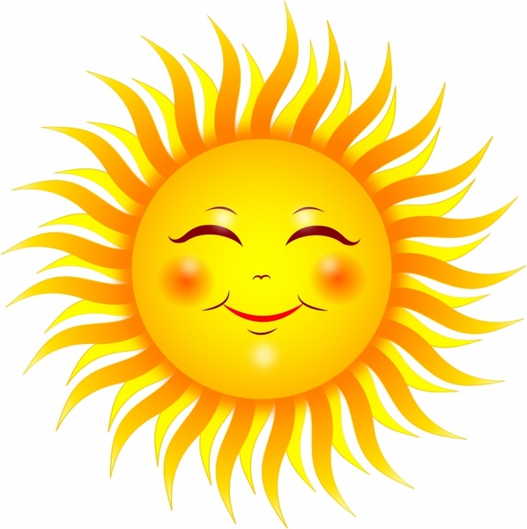

English
Meerkat Mail
The Owl who was Afraid of the Dark
George’s Marvellous Medicine.

Science
Plants
Habitats

History
Nurturing Nurses: The comparison of Florence Nightingale, Mary Seacole and Edith Carvel

Computing
Making Music
Coding

