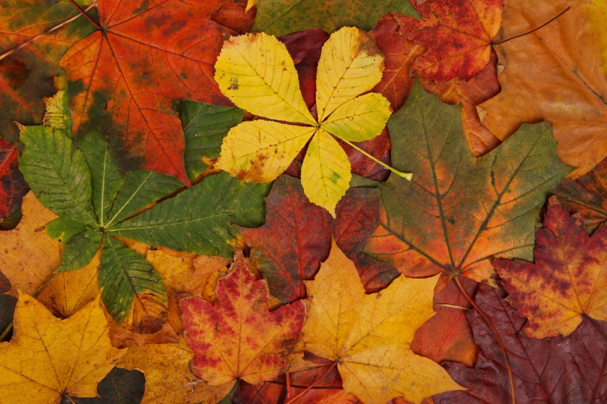

**History**

Southport in the 1960’s

**Geography**

What is a map?

**PE**  
Gymnastics, Fundamentals,

Ball Skills, Invasion Games

**Music**

Pulse, Rhythm and Pitch

**Design Technology**

Making Healthy Pizzas

**Art and Design**

Self Portraits

Peter Blake

**Year 2**

**Autumn Termly Overview**

**Religious Education**

Domestic Church: Beginnings  
Baptism: Signs and Symbols  
Other Faith: Judaism

**Computing**

Information Technology Around Us

**English**

 Wanted! The Perfect Pet

Pumpkin Soup

Firework Poetry

Lighthouse Keepers Lunch

**Science**

**PSHE**Community

Similarities and differences between people

Making informed choices

Types of bullying

Healthy Lifestyles

Animals Including Humans

**Maths**

Place Value

Addition and

Subtraction

Geometry: Shape