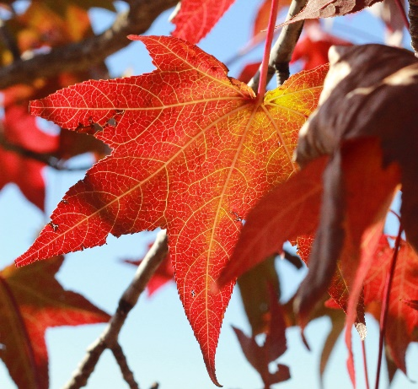

**Autumn Term 1**

**Design and Technology**

Textiles: Puppets

**PSHE**

Belonging to a community.

People who look after us.

**Art**

Self-Portraits.

**Geography**

Taught in Autumn 2.

**History**

Toys -Changes within Living. **emory**

**Toys – Living Memory**

**English**

The Colour Monster

This is the Bear

Focus: Labels and sentences.

**Computing**

**Internet Safety**

**Using Technology -** parts of the computerand basic skills.

**Physical Education**

Fundamental Skills

Ball Skills

(PDS)

**Music**

My Musical Heartbeat.

**Science**

Animals including Humans.

**Maths**

Number Place Value within 10.

Number: Addition and Subtraction within 10.

**Religious Education-Come and See**

Families - God’s love and care for every family (4 weeks).

Belonging - Baptism an invitation to belong to God’s family.

**Year 1**