

**ST. PATRICK'S CATHOLIC PRIMARY SCHOOL**

RADNOR DRIVE • SOUTHPORT • PR9 9RR

TEL: (01704) 225906 • FAX: (01704) 507180

[www.stpatrickschurchtown.com](http://www.stpatrickschurchtown.com)

9th December 2024

Reception Newsletter

**Phonics and Literacy**

We have been consolidating our knowledge of the sounds we have covered so far and using these to practise our reading and writing skills. We enjoyed listening to and talking about the Christmas story and we have written sentences about the story.

**Maths**

We have been practising our counting skills and we have been looking at the composition of four and five. We have talked about and explored different ways of making four and five and looked at how we can represent this using a part-whole model (see example below).

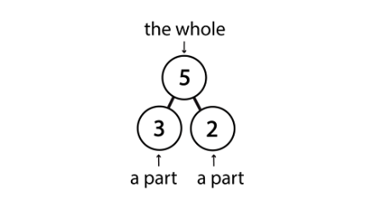

**Topic**

We have continued with our Religious Education topic: Prophecy and Promise. We were so excited to welcome all our families to watch our performances on Tuesday and Wednesday last week and we are so proud of all the children for taking part. This morning we thoroughly enjoyed watching the amazing Year 3 and 4 Christmas performance “The Young Messiah”.

**Homework**

- Please continue to access the Phonics Bug reading books at home as well as your child’s school reading book. Try to read three times a week or every day if possible.

- Could you practise writing the tricky words: he and she?

- Could you practise drawing some part whole models to represent making four and five like in the diagram above?

Many thanks, please contact us if you have any questions, comments or concerns.

The Reception Team



