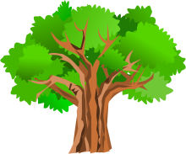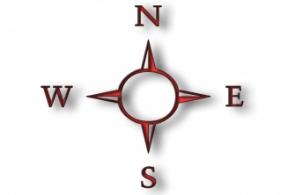**Exploring with your child**

Here are some key geographical enquiry questions, which you might want to use when talking about places to your child:

* Where is this place?
* What does this place look like?
* What links does it have with other places?
* Who lives there and why?
* What is it like to live there?
* Is the place changing and if so, why?
* Why do people visit this place?
* What journeys do people make?
* What do people do here? (occupations, leisure)
* What do you feel about this place?

If you have access to a globe or an atlas at home encourage your child to locate and explore places with you. You might also use websites like Google Earth with parental guidance to do this.

Have fun exploring!